**Delta Kappa Gamma, TN State**

**Iota Chapter News**

Volume 39, Issue 5

March 2024 *Joy Branham, Editor*

Chapter website*:* [*http://iotaxistateweeblycom.weebly.com/*](http://iotaxistateweeblycom.weebly.com/)

Iota Facebook: [*https://www.facebook.com/groups/173164679376911/*](https://www.facebook.com/groups/173164679376911/)

**The mission of The Delta Kappa Gamma Society International is to promote professional and personal growth of women educators and excellence in education.**

***President's Message***

I hope this message finds you all healthy and that you made it through the winter without any issues.  It is hard to believe that it is almost spring.  Seems like it was just Christmas. How time flies!

**Our next meeting will be Saturday, March 2nd at the Press Room of Food City at 11:00 am**.  We will have our **Founders' Day Recognition and Ceremony of Remembrance for Cathy Anderson.** Hostess group #5 is in charge.

We will also **elect our officers for 2024-2026**.  Don't forget to bring items to **donate to Isaiah House--** all new children’s, teens’, and adult size clothing.

***Debi Pelow***

***Iota President***

**Iota Chapter Officers 2022-2024**

PRESIDENT Debi Pelow

VICE-PRESIDENT Mary Shortt

Recording SECRETARY Joan Holt

Corresponding SECRETARY Cathy Anderson

TREASURER Beth Gilbert

MEMBERSHIP Beth Gilbert &

Debi Pelow

YEARBOOK Lisa Holt

WEBMASTER Brenda Moriarty



***Nominations for New Officers Needed—***

We need you! Suggestions for candidates for **president, vice-president, recording secretary, and corresponding secretary for the 2024-2026 biennium are needed**. We need ALL of our Iota sisters to help make Iota chapter a going concern!

If you would be willing to step up to serve for the coming biennium, please let **President Debi Pelow** know. If you have a recommendation for an Iota sister who you think would be an excellent officer, please pass that along too!

**We need to elect officers at the March meeting and install them in office at the April meeting**. Please help all of us!



***Ceremony of Remembrance for Cathy Anderson—***

Our corresponding secretary Cathy Anderson died last December, leaving a huge hole in our membership. Please join us in our Ceremony of Remembrance for Cathy at our March meeting.

***“Catherine Marie Anderson, 72, of Kingsport, went to be with the Lord Tuesday, December 12, 2023.***

***She was born November 3, 1951, in Chattanooga, TN to the late Arthur and Ethel Westbrook.***

***Cathy was a kind and loving Christian lady who loved children and was very supportive of her family and friends.***

***She spent thirty-four years in the field of education, mostly at Westside Elementary. While teaching in Georgia, she was awarded the State Media Center Specialist of the Year Award and was voted "Teacher of the Year" twice. Catherine earned her master's and Ed.S. degrees in education from West Georgia College.***

***She was a member of West Colonial Hills Baptist Church and the Delta Kappa Gamma Society.***

***Cathy enjoyed traveling, attending Christian concerts and conferences.***

***In addition to her parents, Cathy was preceded in death by her husband, Larry Anderson, Sr., brothers, George Westbrook and Howard Westbrook.***

***Those left to cherish Cathy's memory are her son, Larry "Chip" Anderson and his wife, Katy; grandchildren, Silas, Alyshah, Natalie, and David; several nieces and nephews; numerous friends.”***



***Highlights of Our December Meetings—***

* Welcomed our Area I Director **Donna Camper** and TNSO Membership Chair **Pam Egeler** to our Iota meeting.
* Members brought new books to donate to **Girls, Inc.**
* On December 9th, six members of Iota enjoyed fellowship with other chapters from **Area I** at Janie’s Place in Bristol, sponsored by **Alpha Alpha** chapter.

***Order of the Rose—***

Our **2023** nominee for **Order of the Rose was Mary Shortt,** but she had to decline because of prior plans for that weekend. We could have nominated her again, but she says that life has gotten so busy and hectic that she wouldn’t be able to attend this year either.

Therefore, if we intend to nominate an Iota member for Order of the Rose **we must do it before March 15th!** We definitely aren’t required to do this, but we do have wonderful members of Iota chapter that are worthy of this honor. **Before the March meeting**, please think about this and let us know your ideas!



***I don’t know, maybe consult the people who actually do the job?***



**Take action now!**

**Governor Lee's universal voucher program would devastate public schools in every school district in Tennessee.**

* The proposal would provide a over $7000 to families, even those already homeschooling their kids or sending them to private schools.
* Those taking the voucher would be subject to none of the testing or accountability required of public schools, and would have little oversight in how the money was spent.
* There is a proposed cost of over $141 million in year one, after which the cap on voucher students is removed and costs could skyrocket. Some states have seen over 1000% increase in the projected cost of similar programs.
* Paying for a voucher program of this kind would gut state funding in public schools, where the vast majority of kids would still be educated, leaving local governments to make up the difference. If not, services would be cut and staff reduced.

**Please tell your state senator and representative that this is WRONG for Tennessee and ask them to reject school privatization.  Go to this website to send an email to your legislators.**

[**https://secure.ngpvan.com/BzfTRQf3I0GEFZXvnMCM4g2**](https://secure.ngpvan.com/BzfTRQf3I0GEFZXvnMCM4g2)



# 2024 TNSO State Convention The University of the South, Sewanee May 30 - June 1, 2024

# Make plans NOW to attend our state convention! If you haven’t been before, you don’t know what you’re missing!

##### Outgoing and incoming **Chapter Presidents** will be presented at the Presidents' Banquet on Friday, May 31.

##### Be planning our **chapter display** to highlight our past biennium, which will be set up in Convocation Hall on Thursday, May 30.

##### The weekend is chock full of classes, meetings, banquets, the Ceremony of Remembrance (come and join in honoring **Cathy Anderson**), and lots of fellowship.

**You can register online here:** [**https://docs.google.com/forms/d/e/1FAIpQLSdYuGo0V2XRDgMMCijuvZyy8S8YkWKgk9mpREuZV7yIMOUmYg/viewform**](https://docs.google.com/forms/d/e/1FAIpQLSdYuGo0V2XRDgMMCijuvZyy8S8YkWKgk9mpREuZV7yIMOUmYg/viewform)

**Or print out a paper copy to submit here:** [**https://www.tndkg.org/_files/ugd/4ad137_39b5cbde4a554f1c8d82d9ba8e7bb0d8.xlsx?dn=DKG%20TNSO%20Registration%20Form%202024.xlsx**](https://www.tndkg.org/_files/ugd/4ad137_39b5cbde4a554f1c8d82d9ba8e7bb0d8.xlsx?dn=DKG%20TNSO%20Registration%20Form%202024.xlsx)

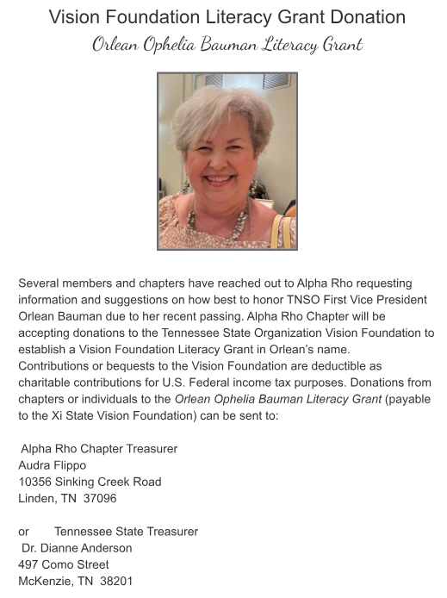

**Orlean was my good friend and a source of joy to everybody in TNSO. Her death was very unexpected and is a huge loss to DKG.**