**Delta Kappa Gamma, TN State**

**Iota Chapter News**

Volume 39, Issue 4

December 2023 *Joy Branham, Editor*

Chapter website*:* [*http://iotaxistateweeblycom.weebly.com/*](http://iotaxistateweeblycom.weebly.com/)

Iota Facebook: [*https://www.facebook.com/groups/173164679376911/*](https://www.facebook.com/groups/173164679376911/)

**The mission of The Delta Kappa Gamma Society International is to promote professional and personal growth of women educators and excellence in education.**

***President’s Message***

The hustle and bustle of the holiday season is upon us. It is my favorite time of year and I have Christmas music playing in my car. I hope you will take the time to pause and enjoy the sights, lights and sounds of the season.  Our next meeting is on **Saturday, December 16**, at the Press Room of Food City at 11:00. **Our Area 1 rep, Donna Camper**, is planning on attending our meeting. **Hostess Group 4** is in charge of table decorations and devotion.  **We will be collecting new, hard-covered books for Girls, Inc.**  I hope to see you all there and hope to see some of you at the **Area 1 brunch on the 9th**.

***Debi Pelow***

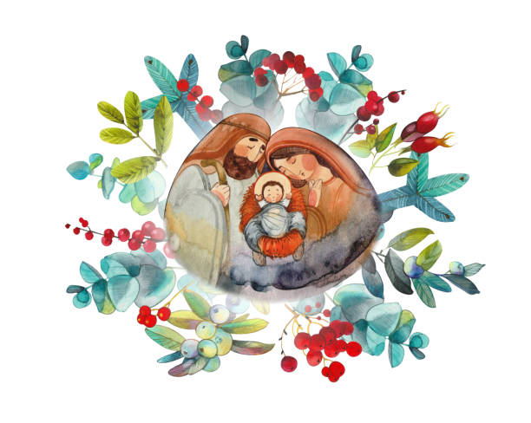***Iota President***

**Iota Chapter Officers 2022-2024**

PRESIDENT Debi Pelow

VICE-PRESIDENT Mary Shortt

Recording SECRETARY Joan Holt

Corresponding SECRETARY Cathy Anderson

TREASURER Beth Gilbert

MEMBERSHIP Beth Gilbert &

Debi Pelow

YEARBOOK Lisa Holt

WEBMASTER Brenda Moriarty

***Highlights of Our November Meeting—***

* **Nina Jones** spoke about the physical and emotional benefits of shag dancing and also demonstrated construction of elaborate Christmas and package bows.
* Members brought donations for the Kingsport **Safe House**.
* November 11th was our meeting date, so the decorations, inspiration, and prayer were all connected to **Veterans Day.**

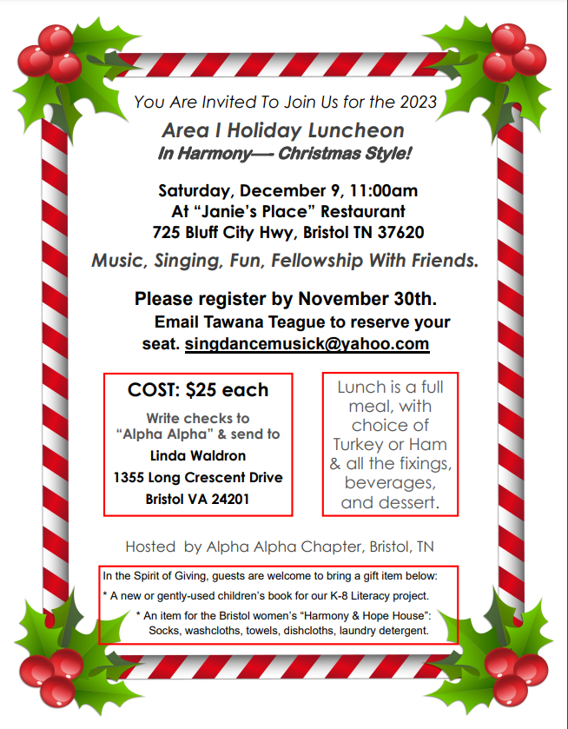

***Personal Growth and Professional Development—***

Whether one is an active or a retired teacher, each of us could benefit from tips to reduce the stress in our lives during the upcoming holiday season.  “Holidays:  Flipping the Script on Stress and Triggers to Calm and Peace” is a blog which offers hints as to how to control the stress engendered by the holidays.  Topics range from “It’s Not About You” to “Stop and Pause Without Saying a Word”, to “Only You Can Control Your Responses.”  These writings offer tips on using gentleness, patience, and love to remove some of the stress we face.  For more information go to www.bringingkingdom.org>blog .