**Delta Kappa Gamma, TN State**

**Iota Chapter News**

Volume 37, Issue 2 October 2021

*Joy Branham, Editor*

Chapter website*:* [*http://iotaxistateweeblycom.weebly.com/*](http://iotaxistateweeblycom.weebly.com/)

Iota Facebook: [*https://www.facebook.com/groups/173164679376911/*](https://www.facebook.com/groups/173164679376911/)

**The mission of The Delta Kappa Gamma Society International is to promote professional and personal growth of women educators and excellence in education.**

***President’s Corner***

Dear Iota Sisters,

We had a great September picnic meeting.  If you were there, you were gifted with a very informative presentation by **Brenda and David Fox** on the "History of Bays Mountain."  Thank you, **Debi Pelow,** for your wonderful work finding interesting and helpful programs for us.

Thank you also to **Beth Gilbert and Debi Pelow** for volunteering to act as  co-chairs of the membership committee.  We have gone a full year without anyone in that very important position.

Our next meeting will be at the ***Press Room Food City, 7 October 2021 at 5:00 PM.***  Hostess Group #4 is in charge. Hope to see everyone there.  Debi has another great program planned for us to enjoy, **Marshall Adesman from the Exchange Place.**

Remember to *bring feminine hygiene products, children's underwear, and socks of all sizes.*

Looking forward to seeing all of you at another great meeting.

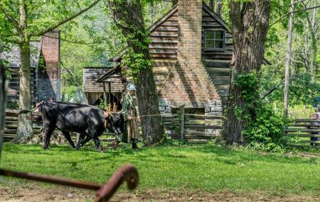***LaMerle Francisco***

**Iota Chapter Officers 2020-2022**

PRESIDENT LaMerle Francisco

VICE-PRESIDENT Debi Pelow

Recording SECRETARY Pat Cox

Corresponding SECRETARY Cathy Anderson

TREASURER Beth Gilbert

MEMBERSHIP Beth Gilbert &

Debi Pelow

YEARBOOK Linda Fontaine

WEBMASTER Brenda Moriarty

***Next meeting 5:00 PM, Thursday, October 7th at Press Room, Food City—***

Hope to see you next week! **Hostess Group #4** will be in charge of table decorations and devotions.

Our program will be presented by **Marshall Adesman** from *Exchange Place.* Our project for this month is items for Iota sister Jeanne Knight’s school, Roosevelt Elementary—feminine products, children’s underwear, and socks. If you still have items for New Teacher baskets, bring those too. Our teachers need all the encouragement they can get!

Since this is a catered meal, it is imperative that you send in your reservation THIS WEEK! Let your **Hostess group chair** know ASAP and please call the number in to **Jane Bowlin** so she can inform Food City.

Looking forward to seeing you there.

***Highlights of Our September Meeting—***

* Potluck picnic at Eastman Shelters. Perfect weather!
* Presentation by **David and Brenda Fox** on the history of Bays Mountain both before and after the park was built.
* Items brought for new teachers. Beth Gilbert volunteered to deliver items.
* Huge thanks to **Beth Gilbert and Debi Pelow** for volunteering to jointly chair the Membership Committee! This post has been vacant for a year.

***From Personal Growth and Professional Development—***

PowerSchool Unified Talent Professional Learning helps teachers plan, track, and manage professional learning.  Online access means distance learning for professional development content is available when and where teachers need it.  To learn more or to see a demonstration go to <https://www.powerschool.com/ppc/pd-retaining%20talent>.



**Joy Branham**, a member for this biennium of the Tennessee State By-Laws and Rules Committee, attended the **Tennessee State Leadership Conference for State Committee Planning** Madison in September. Looking forward to working with a good group this biennium! And we can be proud that we are one of the few chapters that are current on our Rules!