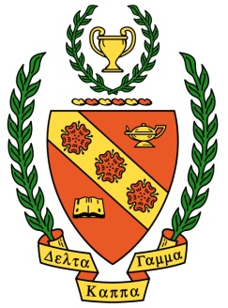**Delta Kappa Gamma, TN State**

**Iota Chapter News**

Volume 37, Issue 4 December 2021

*Joy Branham, Editor*

Chapter website*:* [*http://iotaxistateweeblycom.weebly.com/*](http://iotaxistateweeblycom.weebly.com/)

Iota Facebook: [*https://www.facebook.com/groups/173164679376911/*](https://www.facebook.com/groups/173164679376911/)

**The mission of The Delta Kappa Gamma Society International is to promote professional and personal growth of women educators and excellence in education.**

***President’s Message***

Dear Iota sisters,

Hope your Thanksgiving was perfect, full of family, food, friendship, and all good things. Our December meeting is next **Saturday, December 4**, at the Press Room. Our program will be entertainment by the **Sweet Adelines**. Remember to bring an unwrapped new book for donation to **Girls, Inc**. The lunch Saturday will be spiral sliced ham, green beans almandine, sweet potato casserole, mixed green salad, coconut and red velvet cake for dessert, rolls, tea and coffee. **The price is $16.00.** Blessings on you, and, in case you can’t come to the meeting and I can’t say it in person, then Merry Christmas!

We don’t always know what is going on in each other’s lives, but we should **make an effort to reach out** because almost all of us have challenges that are harder to bear without the support of people who care about us. As Iota sisters, WE CARE! Please let us know what we can do to help, even if it’s just listening.

*LaMerle Francisco*

**Iota Chapter Officers 2020-2022**

PRESIDENT LaMerle Francisco

VICE-PRESIDENT Debi Pelow

Recording SECRETARY Pat Cox

Corresponding SECRETARY Cathy Anderson

TREASURER Beth Gilbert

MEMBERSHIP Beth Gilbert &

Debi Pelow

YEARBOOK Linda Fontaine

WEBMASTER Brenda Moriarty

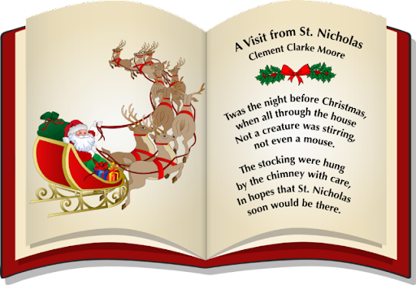

***Next meeting 11:00 AM, Saturday, December 4th at Press Room, Food City—***

Hope to see you next week! **Hostess Group #6** will be in charge of table decorations and devotions. Our entertainment will be a musical production by the **Sweet Adelines**. We’ve delighted in their wonderful singing before and always find it uplifting. Come and enjoy!Our project for December will be bringing new children’s books for the library at **Girls, Inc**. I always have a good time picking mine out. A great excuse to browse the bookstore!

***Highlights of Our November Meeting—***

* Slide show by **Anne G’Fellers Mason**, director of the Heritage Alliance, on the history of schools, both private and public, in Jonesborough.
* Members voted to host the **2022 Area I Christmas brunch** and to cancel the December 2022 chapter meeting.
* Members brought donations for the Women’s Shelter Safe House. Delivered by Joy.



***Personal Growth and Professional Development—***

**The University of Tennessee Center for Professional Education and Lifelong Learning** offers many opportunities for educators to enhance career skills and open new possibilities with Professional Education courses and programs. These varied programs allow educators to set **attainable goals** for one’s own learning whether to pursue career advancement or just to explore a creative diversion that helps one live his best life. For more information go to *non.credit.utk.edu.*

***CALL FOR HELP!***

**Linda Fontaine** has been doing a fantastic job of putting out the **Yearbook** ever since I’ve been a member of Iota and, I’m sure, even longer! After a while, though, it is time to hand the reins over to another member, and Linda has decided that now is the time. Okay, sisters, it’s time for one of you to step up and take it over. Linda has everything on her computer and will put it on a flash drive for you. And you can refer to the template from TN State DKG that can be accessed here: <https://www.tndkg.org/chapter-forms-reports> And, as always Linda and I will be there for you.

Just remember, **we MUST have a new Yearbook Editor**—it’s non-negotiable! And there are too many of us doing double duty right now. We need your help! I want to see a bunch of hands going up!