**Delta Kappa Gamma, Xi State**

**Iota Chapter News**

Volume 32, Issue 6 April 2017

*Joy Branham, Editor*

Chapter website*:* [*http://iotaxistateweeblycom.weebly.com/*](http://iotaxistateweeblycom.weebly.com/)

Iota Facebook: [*https://www.facebook.com/groups/173164679376911/*](https://www.facebook.com/groups/173164679376911/)

***President’s Corner***

Iota Sisters,

It’s a sure sign that spring is here when the garden centers begin to stock their shelves with bulbs, sprouts, tender spring garden plants, and seeds of all kinds. We’re beginning to see that happen all around us. I know the country girl in me is looking forward to doing some digging in the dirt again.

Although we have made some adjustments to our April 8 program, the **fashion show** will go on! **The Dress Barn** has again graciously agreed to allow our members to model some of their new spring fashions. This should be lots of fun!

No doubt the highlight of this meeting will be the **initiation of six** new Delta Kappa Gamma members into Iota Chapter. This number far exceeds our goal set forth in the Strategic Action Plan. **Hats off to the Membership Committee and every member who is sponsoring an initiate.** We want to give these ladies a warm welcome!

As our last meeting before summer approaches, hopefully several of you are planning to attend **Xi State Convention** June 1-3 in Sewanee on the beautiful campus of the University of the South. Registration forms are available on the website, so get yours in early. This is a great opportunity to meet, share, and bond with DKG sisters from across the state. And of course, we are eagerly awaiting news from Xi State concerning **Brenda Moriarty’s** nomination for Order of the Rose.

Our Saturday, April 8 meeting will again be in The Press Room of the downtown Food City at 10:00 a.m. Lunch will be assorted croissant sandwiches, chips, salad and desserts. **Cost will be $14.00.** **Hostess Group 5** is in charge of table decorations and the inspiration. You will need to get your meal reservation to your Hostess Chair by **Monday, April 3**. Remember to bring prizes and snacks to donate to the Bunco Party we will be co-hosting on Tuesday, April 25 and “garden themed” items for the Xi State Silent Auction basket.

Looking forward to seeing everyone again on April 8.

***For aye,***

***Jane***

**Iota Chapter Officers 2014-2016**

PRESIDENT Jane Bowlin

VICE-PRESIDENT Mary Shortt

Recording SECRETARY Becky Sutton

Corresponding SECRETARY Pat Cox

TREASURER Sue Fischer

MEMBERSHIP Martha Ward

YEARBOOK Linda Fontaine

WEBMASTER Brenda Moriarty



***Our April meeting is almost here! We will be meeting at The Press Room (Food City) on Saturday, April 8th, at 10:00 AM.***

Don’t forget to contact your Hostess Group Chair by this weekend and let her know if you will be there or not so that we can plan for food. (Group Chairs, since Mary Shortt will be out of town babysitting for two months, please send your totals to **Jane Bowlin**.) The price of brunch will be **$14.00** this time.

Remember that we will be donating prizes for the Sullivan County Imagination Library **Bunco Party** on April 25th, so if you did not get these to Brenda Moriarty at the last meeting she would surely appreciate them this time.

Also, remember that we are putting together our **Silent Auction basket** for Xi State Convention. Bring anything that you think would be great to include in a basket with the theme of **Gardening**. Get creative!

In addition to Initiation of new members, our program will be a **Spring Fashion Show, by Dress Barn.** Fun for all! Volunteer to model and get a 20% discount if you decide to buy your outfit!

***Highlights of March meeting—***

* Met at The Press Room.
* Ceremony of Remembrance for **Kathryn Lockett and Rosemary Smith**.
* Founders Day program, with biographies of original 12 founders. Photographs of each on the tables. Display of 1960’s scrapbooks by deceased member **Pearl Smith**.
* Panel discussion of publishing by local publisher **Lida Quillen**, owner of *Twilight Times Books*, and local authors, **Chrissie Anderson Peters, Liz Churchwell,** and **Tom Fugate.**
* Welcome of transfer member **Cathy Anderson**, reinstated member **Dianne Montford**, and new member **Beth Gilbert**.
* Six new members were voted into membership, if they will accept—**Casey Bedford**

**Dicey Ford**

**Beth Gilbert**

**Hope Hall**

**Lisa Holt**

**Sarah Poe**

Initiation will be in April.

* **Garden basket theme** was approved for Xi State donation for Silent Auction. Please bring items for the basket to the April meeting.
* **Bring prizes for Bunco evening** to benefit Sullivan County Imagination Library to the April meeting.

***From Personal Growth and Professional Development—***

Sullivan County Schools are offering the following professional development classes:

Tue. April 18   **Improving Family Engagement**

Wed. April 19 **Physical Education PD**

Tue. May 2   **CPR/AED**

For further information or to register,  contact Sullivank12.net/professional development .

***From Membership committee--***

Orientation for four new members was conducted Saturday, March 25, by Martha Ward, Jane Bowlin, and Joy Branham. Martha’s daughter and son-in-law lent the conference room at their Morris Financial offices for the event. **(Thank you, Martha, Jeannine, and Wes!)**

Joy used the PowerPoint she developed to outline Delta Kappa Gamma and to showcase Iota Chapter. On hand to mentor new members were Martha Ward, Linda Smith, Joan Holt, and Jane Bowlin.

New members attending were:

**Lisa Holt**

**Beth Gilbert**

**Dicey Ford**

**Casey Bedford**

Martha and Linda provided refreshments, and good fellowship was provided by all!

A huge welcome to our new members! **Formal initiation will be held at Saturday’s meeting.**

***Legislative Update—***

There has been much in the news lately about President Trump’s proposed budget. Unfortunately, much of it would be disastrous for education and ultimately for children. This is a quote from Network forpubliceducation.org. –

*Donald Trump’s education budget is a declaration of war on public education and our nation’s neediest children. It was surely designed by Betsy DeVos.*

***Trump’s budget would axe after-school programs*** *known as the 21st Century Community Learning Centers which help school districts, churches and nonprofit groups serve more than 1.6 million American children, most of whom are poor. In defending the cuts to such programs,* ***White House Office of Management and Budget Director Mick Mulvaney*** *said after-school programs don’t “show results.” He went on to say that feeding children after-school has never been proven to get them better jobs, so we cannot afford to do it anymore. A full stomach for a hungry child is not good enough–but there is 1.4 billion to send them to voucher schools and for for-profit online learning.*

*The budget also slashes programs that prepare disadvantaged middle and high school students for college. College assistance for first-generation students is also reduced. And if disadvantaged students are still able to get to college, it will be harder for them to stay–Trump’s budget cuts funding for federal work study programs.*

*Our public schools would be hurt. The biggest proposed Trump cut to education is the total elimination of Title IIA funds at about $2.4 billion.  A significant share of those funds is used to keep teachers on staff since the recession. That means increases in taxes or in class sizes.*

You can send an email to your legislators at this address:

<https://actionnetwork.org/letters/do-not-slash-funding-for-disadvantaged-students-to-fund-school-privatization?clear_id=true>

I realize that I am campaigning here, but **this is too important to ignore**.

***Local Student Wins Xi State Scholarship--***

**Sullivan Central student Luke Fox** has won the Xi State High School Essay Contest! Luke receives $300.00 for his first place entry.

Second place was won by Magdalena Hendrickson from Newborn, and third place was won by Madalyn Tate from Spring Hill.

Thanks to **Betty White** and her committee for getting the word out to local schools!

***Make Plans for Xi State—***

For many years now, several members of Iota Chapter have attended the **DKG Xi State Convention in Sewanee the first weekend of June.** Unfortunately, not all of our members have been able to attend. If you have never been, let me urge you to make the effort! You never really realize the importance and impact of Delta Kappa   
Gamma until you have experienced one of the conventions.

Not only is the Convention an

eye-opener about what DKG does, it is also an opportunity to **network** with like-minded teachers from across Tennessee and learn what they are doing to support education and each other.

You can access the registration form here <http://www.xistate.org/forms.htm> . If you can’t open it, let me know and I will mail you a printed copy. I hope to see you there in June!

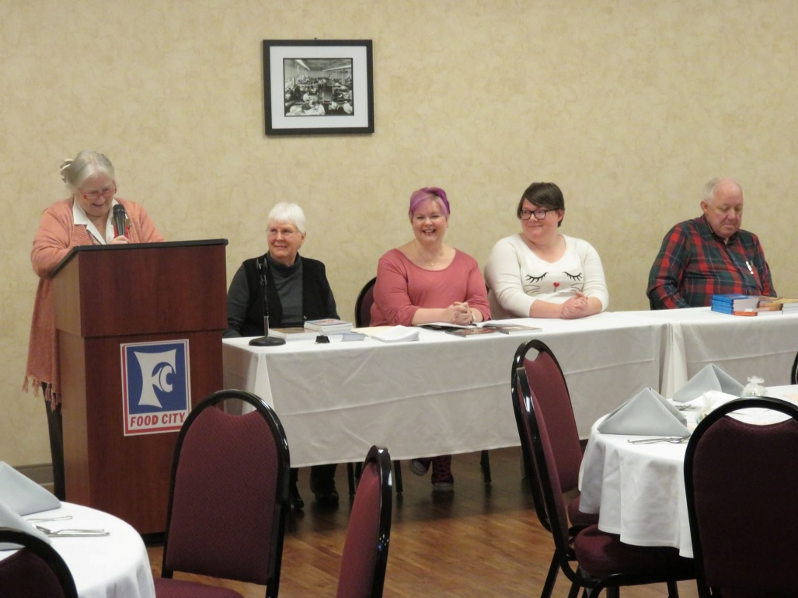***Fun at our March meeting with our panel of local authors and publishers!***

***Ceremony of Remembrance***

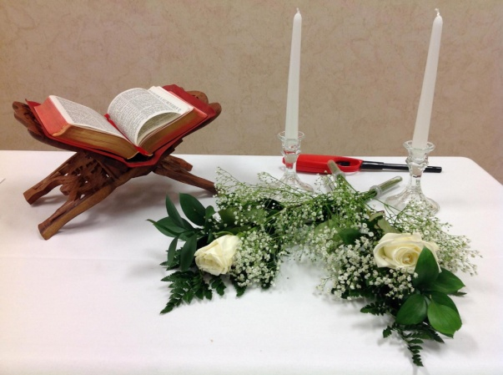



***New initiates at Orientation March 25th—Beth Gilbert, Casey Bedford, Dicey Ford, and Lisa Holt.***