**Delta Kappa Gamma, Xi State**

**Iota Chapter News**

Volume 32, Issue 2 September 2016

*Joy Branham, Editor*

Chapter website*:* [*http://iotaxistateweeblycom.weebly.com/*](http://iotaxistateweeblycom.weebly.com/)

***President’s Corner***

Fellow Iota Sisters,

If you were not in attendance at our August meeting, you really missed a treat! After the summer separation, I think we DKG sisters were craving some “genuine spiritual fellowship.” Our speaker, **Sara Buchanan**, amazed us with her knowledge of literacy and health issues of women in far-away areas of the world. Members came loaded with school supplies to be distributed to teacher workrooms throughout the city and county. A big thank you to **Linda Fontaine, Val Manley, Martha Ward,** and **Tarah Guinn** for packaging and distribution of the school supplies baskets! They were delivered to Jefferson, Roosevelt, and Kennedy Elementary, as well as to V.O. Dobbins Preschool and Head Start Program.

Iota Chapter has received a letter from **Rhoda Bliese, President of Sullivan County Imagination Library,** expressing gratitude for our efforts in registering children for Imagination Library books at the Appalachian Fair. She writes, *“This event has always been the one where more children are registered than at any other event in the year, and this year was no exception. Your outstanding commitment to be there for the entire week of the fair is what made it possible. Registering over 150 children was a remarkable feat. I can’t find words enough to express our deep appreciation.”* Thanks to **Betty White and her volunteers** who “womaned” the booth for the entire six days: **Tammie Davis (friend and sister); Joy Branham; Hannah Guinn; Val Manley and husband, Gale; Mary Shortt; Becky Sutton; myself;** and **Evelyn Edwards** from the SCIL. Another project well done!

Remember to bring your **new member prospect cards** to Martha Ward and the membership committee. Even better—bring a potential member as your guest! Let’s challenge ourselves to increase membership by 10% this year.

**Linda Fontaine** is working diligently to update our **Iota Chapter Yearbook** and needs for you to send her any changes in address, phone, email or teaching position. If you have not already done so, remember to get your $75 yearly dues to Sue Fischer at this meeting or mail them to her right away.

Speaking of our October meeting, we will be hearing from **Wes Morris** of Morris Financial, Inc. and son-in-law of our own **Martha Ward**. He will be giving us pointers on how to manage our savings and investments, and on how to keep us scam-free. Get your meal reservation in to your hostess chair right away. You don’t want to miss this meeting! See you all on October 6.

For aye,

***Jane***

**Iota Chapter Officers 2014-2016**

PRESIDENT Jane Bowlin

VICE-PRESIDENT Mary Shortt

Recording SECRETARY Becky Sutton

Corresponding SECRETARY Pat Cox

TREASURER Sue Fischer

MEMBERSHIP Martha Ward

YEARBOOK Linda Fontaine

WEBMASTER Brenda Moriarty

**Sign up for the October meeting NOW!!—**

Our next meeting will be on Thursday, October 6, at 5:30 PM in The Press Room of the downtown Food City.

Please remember to bring your dues for the year if you have not already—last chance, folks!

Our speaker for this meeting will be Wes Morris of Morris Financial, Inc.  He will be speaking on Scam Artists, Saving, Protecting Your Savings, and Wise Investing.  Wes is Martha Ward's son-in-law. He grew up in Erwin and was a baseball coach at Bluefield College and a PE teacher and coach at Sullivan North and Unicoi County High Schools. He has been a financial adviser since 1999, garnering lots of industry awards with his company.

Hostess Group 1 is in charge of the meeting. Make sure you let Mary Shortt know by Thursday, September 29th, if you will be there so food can be reserved. We will be enjoying soup (white chicken chili), salad, and loaded baked potato bar for $12.00.

***Highlights of August meeting—***

* **Sarah Buchanan** gave information about the US Agency for International Development and Hunger First in Kingsport and some ideas on how we can all make a difference in our communities.
* Recognition of members who have died this year. Joan spoke about **Rosemary Smith** and the foundation that has been started in her memory.
* Martha discussed the proposed new membership cards and **process for recruiting new members.**
* Information was given to the volunteers for the Imagination Library booth at the **Appalachian Fair.**
* **Margaret Bays** gave a big thank you for supporting her and her receipt of the award into the induction of the Hall of Fame of Kingsport City Schools.
* The location of future meetings was discussed. **All will be downtown at Food City except the December 8th meeting which will be held at Holy Trinity Lutheran Church.**
* Mary Short gave out door prizes donated by **Books-A-Million** and a mystery donor.

***From the Personal Growth and Professional Affairs Committee—***

Three of the many workshops slated for this fall available to local teachers are “Effective Classroom Management,”  “Professionalism and Education:  A Common Sense Approach,” and “Section 504.” For more information, contact **teateachers.org./professional-growth-topics**, or call 615-242-8392.

***Support for Teachers Project—***

Thanks to everybody for the items donated at the last meeting for the baskets for teachers! Thought you'd like to see a couple of pictures of our hard-working committee in action!

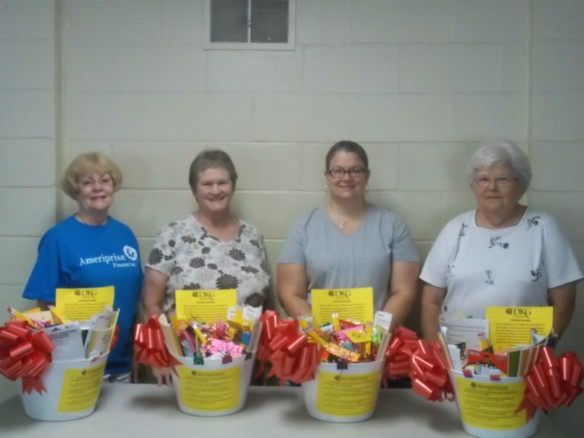

Here's the group who put together the baskets for Kennedy, Roosevelt, Jefferson, and V. O. Dobbins—**Val Manley, Linda Fontaine, Tarah Guinn,** and **Martha Ward**.

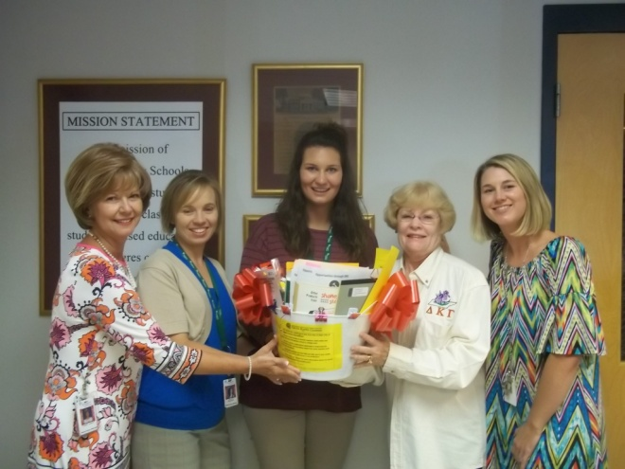

The second picture is of **Val Manley** with some of the teachers at **Jefferson,** who look extremely appreciative of the gift!

Martha would like to remind everyone that we will have the new **member prospect cards** available at each meeting. We already have **one prospective new member**! And if anyone else would like to contribute school supplies you can still bring supplies and we will distribute them to the schools in the area.

***Legislative News—***

**EDUCATION BILLS**

With dozens of education bills before the TN legislature, this one was surprising:

HB2479 and SB2150 will require the commissioner of education to study, at least every five years, **the weight of textbooks** used by students and to make recommendations based on that study to the education committee of the senate and the education administration and planning committee of the house. Visit **http://tn.chalkbeat.org** to access the 2016 TN Education Bill Tracker, under “In focus.”

**CHARTER SCHOOLS AND THE LAW**

In **Louisiana** a lawsuit has been filed by the Louisiana Association of Educators over public funds being diverted to charter schools. In **Washington state** the state supreme court ruled that the state’s charter schools were not entitled to state funds and the state’s charter school law was unconstitutional as a result of a suit brought by the League of Women Voters.  In **Mississippi** the Southern Poverty Law Center brought suit about the funding of charter schools which diverts tax dollars from public schools to charter schools. Current Mississippi law provides that local tax revenue can be diverted from funds designated for public schools to support local charter schools. In **New York** several lawsuits pertaining to charter schools are currently being litigated.  These range from attempts to gain funding to a suit about denial of mandated services for special education students.  In **Texas** charter schools are not governed by state law as to minimum salaries, class size, or enrollment but are still subject to state accountability requirements.  In Texas the lawsuits seek to gain local funding for charter schools.

Laws governing charter schools vary from state to state, but all seem to be having the same sort of trouble that **Tennessee** has been dealing with the past few years. Please keep your finger on the legislative pulse and let your legislators in Nashville know your views on diverting public funds into private businesses.

**LITTLE KNOWN FACTS ABOUT WOMEN IN HISTORY**

There are more than 35,000 museums in the USA and not one includes the full scope of women’s roles and contributions to building our nation.

1. 17-year-old Tennessean **Jackie Mitchell**, the second woman to play in the major leagues, struck out both Babe Ruth and Lou Gehrig in an exhibition game in 1931, but she had her contract voided the next day because the baseball commissioner deemed the sport “too strenuous” for women.
2. In 1777, 16-year-old **Sybil Ludington** rode 40 miles on horseback through the night (twice the distance of Paul Revere’s more publicized ride) to successfully warn Revolutionary Army troops of an impending British attack.
3. Underground Railroad operative **Harriet Tubman** planned and led a successful raid on the Confederacy with 300 Union troops in 1863.
4. In the early 20th century, **Madam C.J. Walker** became the first American female millionaire after creating a line of hair care products for African American women in her kitchen as she tried to make ends meet as a single mother.
5. During the settlement of the American west, former slave **Cathy Williams** disguised herself as William Cathay, enlisted in the army and served undetected for three years as a “Buffalo Soldier.”
6. **Cecilia Payne-Gaposchkin**, the first person to earn a PhD in astronomy at Radcliffe College (then the women’s college of Harvard University) was mocked in her time (1925) for her “ridiculous” theory that the sun is composed primarily of hydrogen.
7. Journalist **Martha Gellhorn** locked herself in a ship’s toilet in order to cover the D-Day invasion of Normandy, eloquently described the momentous event and yet was arrested for defying the ban on female reporters in combat upon her return from the battle.

**SOME WOMEN INVENTORS**

In response to a request to include more information about **women’s successes**, I offer the following:

It was not until the late 1800s that women could be the owner of record for property or enter into legal agreements in their own name. Instead, a woman's property was in the name of her father or husband.  **Sybilla Masters** may have been the first American woman inventor. She invented a new corn mill, but was denied a patent in 1712 because she was a woman. Three years later the patent was granted when it was filed in her husband's name.

Some other interesting inventions by women are the Apgar Test credited to **Virginia Apgar** in 1952, the disposable diaper patented by **Marion Donovan** in 1950 and the dishwasher invented by **Josephine Cochran** in 1872.  Lest you think that women invented only things for the home, note that the windshield wiper was invented by **Mary Anderson** in 1903, the rotary engine patented by **Margaret Knight** in 1904 and the engine muffler exhaust credited to **El Dorado Jones** in 1917.