**Delta Kappa Gamma, Xi State**

**Iota Chapter News**

Volume 28, Issue 2 September 2012

*Joy Branham, Editor*

***President’s Corner***

Dear DKG sisters,

We began our new year with an exciting and eventful first meeting!!  We could have started our own teacher's supply store with the amount of things brought to fill new teacher goodie bags.  What an awesome group of women, 28 in attendance, who care and share!!  There was a slide show during the meeting that showed pictures of children’s faces as they were given the opportunity to register for books from the Imagination Library...217 in all.  There were informative committee reports, inspirational music by Rosemary Smith and absolutely the most delicious desserts ever!!   Thanks to Hostess group 1.

It will be tough but I bet the next meeting at **Yancey Tavern** (an all-time favorite) will supersede the first!  Joy Branham has a **quilting program** designed for us as only Joy can do. We'll have to get on board because she has a PLAN.  We're all going to be in this together! We'll have some specific committee reports as well.

 We'll have special music as well as delish desserts and drinks from **Hostess group 2.**

Everyone else please **bring your favorite covered dish**.

Find a friend and invite her to the meeting. Let her see what a great time this group of teachers have with each other and how we can be an influence and contribute to the teaching profession (women in particular) and also how we can impact educational issues that affect children.  Joy has sent via e-mail a **petition** to be signed on behalf of The National Women's History Museum to be built in Washington, D C.

From this platform, Delta Kappa Gamma, we can speak out and be heard!!!

I look forward to seeing all of you.

Blessings,

***Joan Holt***

**Iota Chapter Officers 2012-2013**

PRESIDENT Joan Holt

VICE-PRESIDENT Trisha Harris

Recording SECRETARY Pat Cox

Corresponding SECRETARY Brenda Moriarty

TREASURER Sue Fischer

MEMBERSHIP Rachel O'Dell

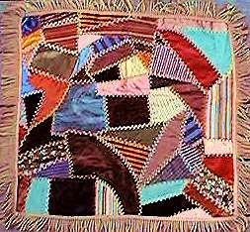YEARBOOK Linda Fontaine

PROGRAM Martha Rhoton

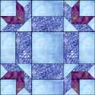**Our next meeting will be at Yancey Tavern on Saturday, October 6, at 10:30 A. M. This is a potluck, so show off your most luscious dish! Remember, it is also a Quilt Show & Tell, so dig out that gorgeous old (or new) quilt to share.**

*Cook’s Corner*

**Cherry Chocolate Cake**

***(Sue Thomas)***

1 box Duncan Hines devil’s food cake mix

1 can of cherry pie filling

2 eggs

1 to 3 teaspoons almond flavoring

*Mix by spoon.  Bake in a greased 9x13 pan at 350 degrees for 30-35 minutes*.

Icing:

1 cup sugar

5 tablespoons butter

1/3 cup milk

1 (6 oz.) pkg. of chocolate chips

*Heat sugar, milk and butter to a boil and cook one minute.  Add chocolate chips and beat with mixer until smooth.  Pour over warm cake.*

**German Chocolate Pecan Pie Bars**

***(Linda Smith)***

3 cups pecan halves and pieces

1-¾ cups all-purpose flour

¾ cup powdered sugar

¾ cup cold butter, cubed

¼ cup unsweetened cocoa

1-1/2 cups semisweet chocolate morsels

¾ cup firmly packed brown sugar

¾ cup light corn syrup

¼ cup butter, melted

3 large eggs, beaten

1 cup sweetened flaked coconut

(I added salt--¼ tsp. to crust and ¼ tsp. to filling.)

Preheat oven to 350 degrees.  Toast pecans in a single layer in a shallow pan about 5 minutes or until lightly browned and fragrant; stirring halfway through baking time.

Line bottom and sides of a 13-x 9-inch pan with heavy duty aluminum foil, allowing 2-3 inches to extend over sides.  Lightly grease foil. (I sprayed with Pam.)

Pulse flour and next three ingredients (plus salt if adding) in a food processor until mixture resembles coarse meal  Press mixture on bottom and ¾ inch up sides of prepared pan.

Bake crust in preheated oven for 15 minutes.  Remove from oven and sprinkle chocolate morsels over crust.  Cool completely on wire rack, about 30 minutes.

Whisk together brown sugar and next three ingredients (plus salt if adding) until smooth.  Stir in coconut and toasted pecans; spoon into prepared crust.

Bake at 350 degrees for 25 to 30 minutes or until golden and set.  Cool completely on wire rack (about 1 hour).  Chill 1 hour.  Lift baked bars from pan using foil sides as handles.  Transfer to cutting board and cut into bars.

**Apricot Almond Torte**

***(Linda Smith)***

3 eggs

1-1/2 cups sugar

1 tsp. vanilla extract

1-3/4 cup all-purpose flour

1 cup toasted slivered almonds, ground

2 tsp. baking powder

½ tsp. salt

1-1/2 cups heavy cream, whipped

*Frosting:*

1 8-oz. block cream cheese, softened

1 cup sugar

1/8 tsp. salt

1 tsp. almond extract

1-1/2 cups heavy cream, whipped

1 10-12 oz. jar apricot preserves

½ cup slivered almonds, toasted

Grease and flour two 9-inch round cake pans.  Line with either waxed paper or parchment paper rounds.  Spray paper with Pam.  In a large bowl, beat eggs, sugar, and vanilla on high speed until thick and lemon-colored.  Combine flour, ground almonds, baking powder, and salt; gradually fold into egg mixture alternately with whipped cream.  Divide evenly between prepared pans.  Bake in a preheated 350 degree oven for 22-28 minutes or until a toothpick inserted in center comes out clean.  Cool in pan on wire racks for 10 minutes before removing from pans to racks to cool completely.

In a large bowl, beat cream cheese, sugar, and salt until smooth.  Beat in extract.  Fold in whipped cream.

Cut each cake layer horizontally into two layers.  Place bottom layer on serving plate; spread with 1 cup frosting.  Top with another cake section; spread with half of the preserves.  Repeat layers.  Frost sides of cake; decorate top edge with remaining frosting and sprinkle with almonds.

**Note:**  For frosting, I substitute a medium sized Cool Whip; it holds up better than whipped cream.  DO NOT substitute Cool Whip for whipped cream in the cake itself.

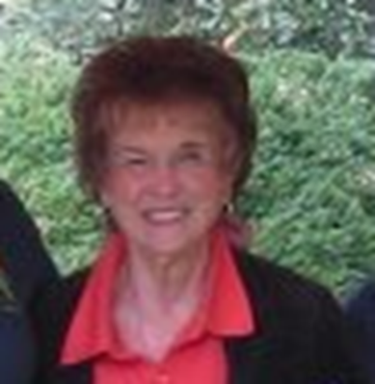

**Member News—**

Congratulations to **Margaret Bays** on her daughter’s *National Interior Designer of the Year* award! LuAnne Bays, Mountain Home VA Medical Center Interior Designer was named “Interior Designer of the Year 2012” at a national Environmental Program Service Interior Design Conference in Chicago. LuAnne was recognized by her peers in the area of project management and coordination, out of 154 VA hospitals.

Margaret has been a member of Iota

Chapter, 😐 since 1967. She taught music in Kingsport City Schools for many years, long enough to become a legend in the system, retiring a couple of years ago. Margaret and Vernon Bays were always staunch supporters of Kingsport Education Association, which is how I originally met Margaret. Margaret and Vernon had two daughters—LuAnne, and Gwen, who is the office supervisor at the ETSU University Center.

Say Happy Birthday to Margaret on October 11th!

***Highlights of September Meeting—***

* Installation of officers was held.
* Initiation of new members was postponed to another meeting
* JoAnn Smith, formerly a member of Alpha Alpha chapter, transferred to Iota. JoAnn is president of Tennessee Retired Teachers Association and Sullivan County Retired Teachers Association.
* Joan Holt showed the awards that Iota received at Xi State in June—Bronze Award for Chapter Excellence, Honor Chapter for Chapter Growth, and Highest Honors for Yearbook and Communications.
* Voted to welcome Amanda Cox, third year teacher at Sevier Middle School, as a new member.
* Joan Holt reported that we signed up 217 children for Imagination Library at the Appalachian Fair.
* Martha Rhoton and Joy Branham talked about the quilt project that will be the program at the October meeting at Yancey Tavern. Members are asked to purchase a $5.00 kit to make a quilt block. The blocks need to be returned in November so they can be sewn into a quilt that will eventually be used as a fundraiser for Iota Chapter.

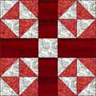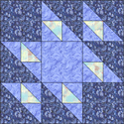

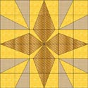

*Quilt show at Netherland Inn*

**Cynthia Livesay’s** **grandmother’s quilt** is going to be featured in the Netherland Inn FALL QUILT SHOW Oct. 5-7

Oct. 5th ----12pm-5pm

Oct. 6th ---10am-5pm

Oct. 7th ----1pm-5pm

Admission to quilt show is $5.00--- students under 10, no charge if with a paying adult. Call 677-1640 for additional information

SPECIAL ACTIVITIES

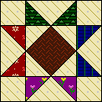• Quilt Show

• Quilting Demonstrations

• Food

• Learn more about the Downtown Quilt Trail

• Join with local quilt organizations to learn the art of quilting

• Tour the only registered historical site which was both a stage coach stop and a

boatyard

You are invited to bring your “homemade bed quilts”, hand quilted or machine quilted; contemporary or antique quilts; baby or crib quilts; wall hangings and lap quilts. Your quilts can be brought to the Inn on Oct 3 from 9am-1pm. Come, bring a friend…Enjoy touring the historical inn; learn something new!

Petition for a Women’s History Museum in Washington, D. C.—

I sent the website concerning this to those for whom I had email addresses. If you aren’t into email, please contact Congress by letter to address the issue. Here is a sample letter:

**Petition Letter**

Greetings,   
  
House Speaker John Boehner, Senate Majority Harry Reid, House Majority Leader Eric Cantor, House Minority Leader Nancy Pelosi, Senate Minority Leader Mitch McConnell,   
  
I urge Congress to pass legislation that would provide a permanent home for women’s history on the National Mall. Did you know that only one in ten figures in today’s history textbooks is a woman; less than eight percent of the statues in our national parks are of women and in our nation’s Capitol Building, only thirteen out of the 217 statues are of women leaders? The National Women’s History Museum (NWHM) will educate and empower by building a museum in Washington, DC, a city whose attractions symbolize what our nation honors.   
  
NWHM has petitioned Congress for a permanent home on or near the National Mall, offering to build the Museum with private monies, not at taxpayer’s expense, for the last nine years, yet our efforts continue to be blocked. Congress’ inaction includes:   
• Passing legislation twice in the U.S. Senate but not passing it in the House of Representatives  
• In another session of Congress, passing legislation in the House but not in the Senate.   
• Then during this Congress, attaching a pet-project killer amendment to our bill which hasn’t passed – and won’t.  
  
There is one vacant site left on the National Mall – it is time for Congress to act now! Do not make women wait even one more year to gain the recognition they deserve. Make your voice heard and let Congress know that you want women’s history on the National Mall.   
  
New legislation has been drafted and will be introduced soon. Time is short. In this election year, there is no reason why this can’t be one issue that garners bi-partisan support!  
  
I urge you to pass legislation allowing the National Women’s History Museum to have a home on the National Mall!  
----------------  
Sincerely,  
  
[Your name]

"Once children learn how to learn, nothing is going to narrow their minds. The essence of teaching is to make learning contagious, to have one idea spark another." *-- Marva Collins*

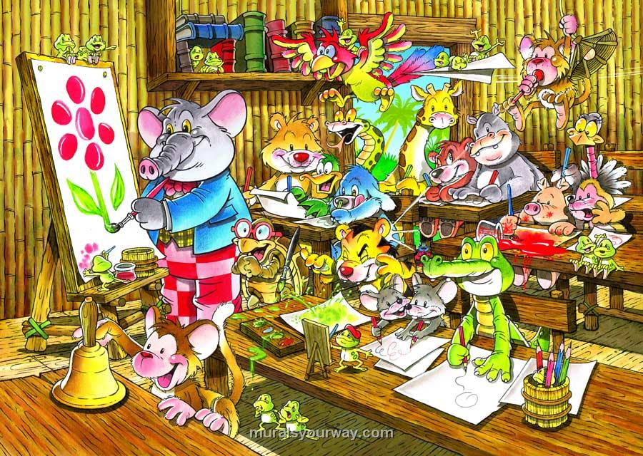 Remember—It’s a jungle out there! Be safe, and don’t let the carnivores get you down!

Have a great year!