**Delta Kappa Gamma, Xi State**

**Iota Chapter News**

Volume 28, Issue 3 October 2012

*Joy Branham, Editor*

***President’s Corner***

DKG sisters,

I'm overwhelmed with the beautiful fall colors this year, expecially the awesome pictures my friends share on Facebook.  We are so blessed to live in this part of the country!  And we're going to be blessed once again by the talents of our speaker, **Pam Archer**, for the November 1 meeting.  She will be preparing us for the holiday season with secrets for decorating and entertaining.

Hostess Group 4 will have a most festive surprise for all of us with the meal being catered by the Mustard Seed.  You will be delighted with entertainment by an amazing young man, **Samuel Brown**, who attends DB and Litz Manor Church.

Hope all of you are having some success with your quilting project that Joy presented at our meeting at Yancey Taven.  We'll be checking those out.

I have received 7 responses to attend the **Area 1 luncheon** on Dec. 1.  They are Joy, Belinda, JoAnn, Trish, Val, Joan and Rosemary. Please let me know ASAP if you would like to attend.

I look forward to see each of you on Thursday, November l, at 5:30 at Litz Manor Baptist Church.

Blessings,

***Joan Holt***

**Iota Chapter Officers 2012-2013**

PRESIDENT Joan Holt

VICE-PRESIDENT Trisha Harris

Recording SECRETARY Pat Cox

Corresponding SECRETARY Brenda Moriarty

TREASURER Sue Fischer

MEMBERSHIP Rachel O'Dell

YEARBOOK Linda Fontaine

PROGRAM Martha Rhoton

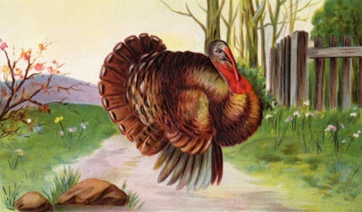

Our November meeting will be at Litz Manor Baptist Church on **Thursday November 1st**, at 5:30 P. M. The Mustard Seed will be catering. Cost will be at the most $7.00. ***Pam Archer*** will present "HOLIDAY DECORATING MADE EASY," and those of us who neglected to bring our quilts at the last meeting will try to remedy that this time! Also, if you have finished your ***quilt block*** for the raffle quilt, please bring it back at this meeting**.**

***Christmas brunch--***

**Gamma Mu’s president Beverly McKinney sent us this invitation:**

The Area 1 DKG Christmas Brunch will be on Dec. 1, 2012 at 11 A.M. We will meet at Red Tail Golf / Country Club, Hwy 421 S. in **Mountain City**.

The theme is "An Appalachian Christmas". Decorations will reflect Appalachian culture - several decorated trees, quilts, hand made table favors,etc. **Nancy Davis's** Middle School Singers will be entertaining us with singing and Mrs. Minnie Miller will speak and we’ll have good food to eat.

Cost is **$20** per person; number attending and **money should be sent no latter than Nov. 15th**.

Our chapter has not been big supporters of the brunch in the past with only two or three members attending even though everyone talked about how great it was. This year we suggested that we host the event and our members got really excited about sister chapters coming here. Besides wanting to see everyone, we hope that other chapters will follow example and will volunteer to host - therefore more involvement.

C:\Program Files\Microsoft Office\MEDIA\CAGCAT10\j0183290.wmf**State President Kathie Harned** will be attending.

Please come be with us.

**I’m hoping Iota Chapter members will accept Gamma Mu’s invitation. You’ll enjoy it!**

***Timely information from the U. S. Forum of 😐 International—***

**IMPORTANT CELL PHONE INFORMATION**1.      Protecting your cell phone – press *#06# and your the phone will display its unique handset number.  Write the number somewhere for safe keeping.  If your phone is stolen, you can call your cell phone provider, report the loss and give this number to your service provider.  The company can then disable the phone rendering it useless to the thief.  
2.      You can access free directory service from your cell phone by dialing 800free411, you will want to program this number into your phone.  If you simply dial 411, your cell phone provider will charge you between $1 and $1.75 for each directory assistance call you make. This free link is funded by McDonald’s.  
3.      A local worldwide emergency number to use is 112.  This will cause your phone to search and locate nearby emergency services.  
4.      If your cell phone battery is low, it is possible to access some additional power by dialing *3370#.  This will increase the remaining power by about 50% from a power reserve which will be replenished when you charge the phone the next time.  
  
***WHY YOU SHOULD VOTE***WOMEN IN THE UNITED STATES HAVE HAD THE RIGHT TO VOTE FOR LESS THAN 100 YEARS. EXERCISE YOUR RIGHT TO VOTE ON TUESDAY, NOVEMBER 6, 2012.

On November 6, 2012 voters in the United States will be choosing many of the people who will be in charge of governing our nation for at least two years.

For 80 years dedicated groups of women worked and sacrificed to get you the right to vote.  They chained themselves to fences, were incarcerated, went on hunger strikes, were force fed and organized protests and picket lines. Beginning with Susan B. Anthony and Elizabeth Cady Stanton in 1840 and ending with Alice Paul and Lucy Burns in the early 1900s many women sacrificed much to gain women the right to vote.

(Alice Paul’s degrees included M.A., PhD and LL.B degrees. **An educated woman is a force to be reckoned with.**)

***Highlights of October meeting—***

* Covered dish lunch at Yancey Tavern.
* Several guests added to our festivities!
* Committee reports from Sue Fischer, Linda Smith, and JoAnn Smith.
* Belinda Castille was initiated into Iota Chapter.
* Mary Faulkner spoke about the Downtown Kingsport Quilt Trail.
* Joy Branham introduced our quilt project to raise funds for scholarships and had quilt packets for sale to members, all money going to Iota.
* Members had a quilt “show and tell” of beautiful personal quilts.
* Music was provided by a Men’s Ensemble from First Broad Street United Methodist Church.

***Recipes for Iota Cookbook!***

Martha Rhoton

Several ladies have said they would like to share recipes. This will NOT be a cookbook, but if you will send me up to **three** of your favorite recipes, I will type them up and run them off and staple them together. (Or if anyone has a computer program that would do that, you may certainly volunteer!!!!!!! ) Please either e-mail, snail mail, or hand me a copy of the recipes. I need these by November 18 please. I must get this finished before Thanksgiving.

Also, please, please, please check and double check the recipe for **accuracy**. It is so frustrating to be cooking a recipe and something is left out or the instuctions are not clear. I go back over the recipe and "mentally" cook it to see if I need to add anything. Have a name for the recipe and include your name. Any nice info about it would be enjoyable, too.

I asked for a recipe for a wonderful cinammon loaf and the person said to go into the right side of Walmart and turn right and find it in the bakery!! That kind of recipe is great, too!!!!

*Cook’s Corner*

**APRICOT--PINEAPPLE SALAD (Baby Food Salad)**

*Linda Fontaine*

1 – 8 oz. can crushed pineapple (undrained)

1 – 3 oz. package orange jello

2 small jars strained apricot baby food

1 – 8 oz. package cream cheese (softened)

1 – 8 oz. Cool Whip

¾ cup sugar

Combine pineapple and jello in small sauce pan.  Stir over low heat until dissolved.  Remove from heat.  Add sugar, baby food, and cream cheese.  Mix well, but do not beat.  Chill until thick.  Fold in Cool Whip.  Sprinkle with nuts, if desired.

**CONGRESSIONAL BEAN SOUP**

*Martha Rhoton*

(I don't know if it is called congressional because it has ham in it or because it is full of beans!!!) (This is what I took to the last meeting.)

1 lb. dried small white beans

8 cups water

1 meaty ham bone or 2 cups diced cooked ham *(I use Jeno's Turkey ham that you buy in a chunk.)*

1 cup finely chopped celery

1 onion, finely chopped

1 tsp. salt

1/4 tsp pepper

1 bay leaf

In large pan, heat beans in water. Boil gently for 2 minutes, turn off heat, and let stand 1 hour. Pour into slow-cooking pot. Add remaining ingredients. *(All that water will not fit into my crockpot, so just pour off the extra.)*

Cover and cook on low for 12 to 14 hours or until beans are very soft. Remove bay leaf and ham bone. Cut meat off bone and return meat to beans. Makes 6 to 8 large servings*. (Beans may be soaked overnight if preferred.)*

***Credit Card Vulnerability***

I just got an email from my sister’s computer tech friend about a Radio Frequency chip that is being embedded in credit cards, which is extremely vulnerable to ID theft. This has far-reaching consequences for everybody. Please look at the interview that was done on TV Channel 13 Eyewitness News:

<http://youtube.googleapis.com/v/lLAFhTjsQHw%26sns=em>

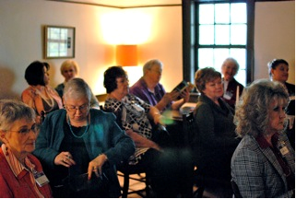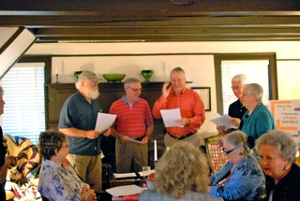

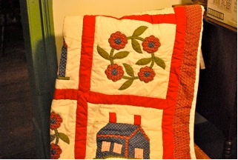

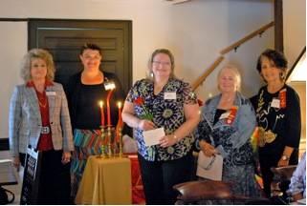

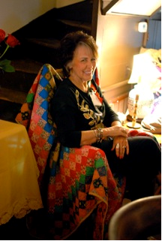

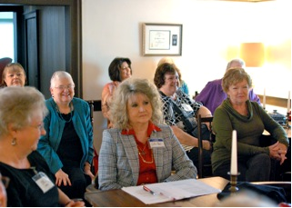

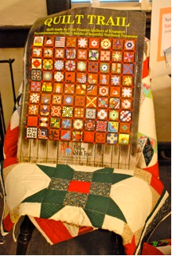

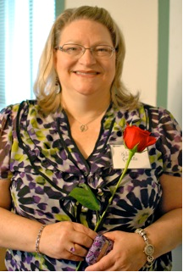

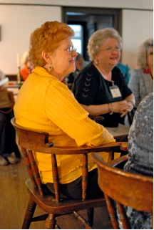

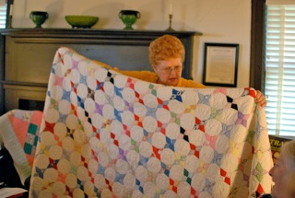

***Fun times at our October meeting!***

