**Delta Kappa Gamma, Xi State**

**Iota Chapter News**

Volume 32, Issue 1 August 2016

*Joy Branham, Editor*

Chapter website*:* [*http://iotaxistateweeblycom.weebly.com/*](http://iotaxistateweeblycom.weebly.com/)

***President’s Corner***

Fellow Iota Sisters,

Where on earth is summer going? Even as we are fully absorbed in summer activities, your officers and committee chairs have been busy planning for the upcoming year. Projects will include the continuation of our literacy focus through volunteering at the **Dolly Parton Imagination Library booth at the Appalachian Fair August 22-27**. Be sure to contact **Betty White** if you are able to volunteer for a shift at the fair.

I attended **Xi State Chapter Leadership Training** in Murfreesboro on April 23 gaining ideas to strengthen our chapter. Joy Branham and I had an exhilarating experience at the early June **Xi State Convention in Sewanee**, bringing home a host of chapter awards. We can all be proud of Iota Chapter's accomplishments brought about through the efforts of a host of hard-working members. Joy and Val Manley also attended **International Convention in Nashville** and will have lots to report at the first opportunity.

Mary Shortt has invited an intriguing young woman**, Sara Buchanan**, to speak to us at our **first meeting of the year on Saturday, August 20**, so make plans now to attend. Enjoy the rest of your summer!

For aye,

***Jane***

**

**Iota Chapter Officers 2014-2016**

PRESIDENT Jane Bowlin

VICE-PRESIDENT Mary Shortt

Recording SECRETARY Becky Sutton

Corresponding SECRETARY Pat Cox

TREASURER Sue Fischer

MEMBERSHIP Martha Ward

YEARBOOK Linda Fontaine

WEBMASTER Brenda Moriarty

***Save the Date—August 20th at 10:00 A.M!*** *(not 10:30)*

**First meeting of the year, at the Press Room in Food City on Eastman Road. The brunch is $12.00. Hostess chairs, please make sure you *contact Mary Shortt by August 15th with the number of people attending* because Food City will have to make arrangements for the meal. Hostess Group 6 will be in charge of decorating tables and presenting the inspiration.**

**We will also be collecting *classroom supplies* for new teachers at this meeting.**

We are excited to have as our speaker **Sara Buchanan**, a Lynn Garden native now working in the diplomatic Foreign Service with the United States Agency for International Development (USAID) as Democracy and Governance Officer.

Be sure to tell everyone in your groups to try to attend and **bring a guest** if they can to hear her. She will speak **first,** and then we will eat. Guests can leave after we eat if they like (*but we would love for them to stay and find out about DKG and maybe return as a* ***new member****!*). And, Mary has arranged for treats and door prizes!

***A Little More About Sara—***

*(I don't know about you, but I am seriously impressed!)*

**Education:**

Master of Public Health, December 2008

University of Alaska, Anchorage

Public Health Practice

Thesis: “Improving Child Survival through Behavioral Change and Community Engagement: The Farta Child Survival Project” 113 pp.

Master of Arts, August 1998

University of South Carolina, Columbia, South Carolina Government and International Studies

Emphasis: Middle Eastern/Islamic Studies

Thesis: “After the Intifada: Palestinian Women and Gender Relations in the Occupied Territories” 120 pp.

Bachelor of Arts, May 1996

Bradley University, Peoria, Illinois

History and Political Science

Magna Cum Laude

**Selected Publications/Presentations**

Primary author with Ambrose Olaa: “Calling the Shots: Women Mend Fault Lines of Conflict in Uganda.”  *USAID* *Frontlines.*January/February 2013.

Primary author with Barbara Pose: “Improving Child Survival through Behavioral Change and Community Engagement: The Farta, Ethiopia Child Survival Project.” *International Journal of Health Education and Promotion*, June 2012, v. 50: 3. pp. 145-158.

“Stopping Child Marriage: Lessons from Ethiopia”. Presentation to the United Nations Commission on the Status of Women, New York, NY, February 22, 2008.

With Haregewein Admassu: “CARE’s Strategic Impact Inquiry on Women’s Empowerment and FGC Elimination in Awash”. Presentation to the United Nations Global Consultation on Female Genital Cutting/Mutilation in Addis Ababa, Ethiopia, July 31-August 3, 2007.  

**Employment:**

Since 2010, in the diplomatic Foreign Service with the United States Agency for International Development (USAID) as Democracy and Governance Officer, serving in Afghanistan, Uganda, and Kosovo (and soon in South Sudan).

2008-2010 USAID Democracy Specialist, Uzbekistan

2007-2008 Senior Advisor for Program Quality, CARE International in Ethiopia

2005-2008 Program Development Officer/Gender Advisor, CARE International in Afghanistan

2002-2004 Special Assistant to Mission Director, USAID Kazakhstan

2001-2002 Grants Manager, Women's Independent Democratic Movement (local NGO), Belarus

1999-2001 Peace Corps Volunteer, Kazakhstan

**Languages:**

Russian.

***2016 Xi State Essay Contest***

Congratulations to high school senior **Katerina Johnson** from **Sullivan South High School**, who won **3rd place** in the 2016 Xi State Essay Contest and was awarded a $100.00 scholarship! She was sponsored by Iota Chapter.

Many, many thanks to **Betty White** for making sure that the guidance counselors and English teachers of the local high schools had the information for the essay contest. Having done that, I know how frustrating it can be not to have any response, so this year is very encouraging!

***Iota Chapter Quilt Scholarship***

After studying several entries for our Iota Chapter Quilt Scholarship from area high schools, the Awards Committee chose **Brooke Lawson** from Gate City High School, who will be attending ETSU, as our recipient! The committee had this to say about her: *"We were impressed that you supported your reasons for wanting to enter the field of Elementary Education by the fact that you did job shadowing and worked with younger children. Your appreciation for the work ethic of your family showed that you know the value of hard work to reach your goals. Your community involvement and desire to impact the lives of others showed organizational skills and maturity. All of these points reflected the high standards you have set for yourself and led us to choose you as DKG's Scholarship recipient."*



***We've Been Published!***

Check out the June/July issue of ***Quilters Newsletter Magazine***—our scholarship quilt made the Quilting Bee section, which takes pictures from readers. This means they **really, really** liked our quilt, since there are so many submitted!

***Highlights of April meeting—***

* *Tea was held at Holy Trinity Lutheran Church, complete with hats and all the elegant paraphernalia!*
* *New member Lacy Hughes was initiated.*
* *New officers were installed.*
* *Fond farewell was said to outgoing president JoAnn Smith who has moved to Alabama.*
* *Drinks-related items were brought for our Xi State Silent Auction basket.*

***Legislative News—***

**ESSA PROBLEMS**

There are potential problems brewing between Congress specifically between the Senate Health Education, Labor and Pensions Committee and the newly confirmed Secretary of Education John King. **The essence of the disagreement is how Title I funds would be spent.**  There is concern that instead of federal money being used to supplement local funding to adequately staff Title I programs, the money will be used for routine expenses thus limiting the money needed to carry out the intent of Title I funding.  Senator Alexander indicated that he is willing to use Congressional appropriations to insure that congressional intent is heeded.  With a new president and, presumably, a new Secretary of Education taking office after the first of the year, this disagreement has the potential to cause problems with the implementation of the new education law.  (For more detailed information on this issue go to <https://www.washingtonpost.com/news/answer-sheet/wp/2016/04/13/didnt-take-long-new-education-secretary-starts-butting-heads-in-nations-capital/>

**REVISED GED STANDARDS**

The GED Testing Service has recently **lowered the passing score** for the test.  This will allow states to lower the score needed to pass the GED.  Every section will go from 150 of 200 to pass to 145 of 200.  This is retroactive and is estimated to result in approximately 25,000 additional individuals passing the GED based on exams they have already taken.  States would have to agree to make the change.

**RETROACTIVE DIPLOMAS**

With the change in required exit exams to get a high school diploma, some states are **granting high school diplomas retroactively to students who failed the state exit exams but who passed the coursework** which the state now requires.

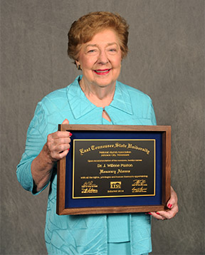

**Death of Dr. Willene Paxton**

Former Xi State president and ETSU Dean of Women Willene Paxton died while on a trip to London, England, in July. Many of you who didn't remember her from ETSU met her several years ago when she was Area I Director for DKG. Willene was vibrant and active all her life, a force to be reckoned with! We will miss her.

**Death of Kathryn Lockett**

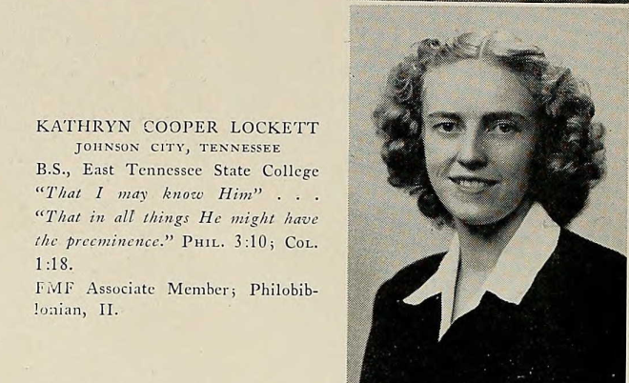

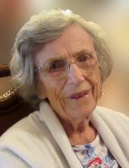

Kathryn Cooper Lockett, 97, died at home on **Friday, July 29, 2016** in Johnson City, TN. She was the daughter of the late Edgar N. Lockett, Sr. and Lucy Kathryn Lockett. She was born in Johnson City July 5, 1919.

She graduated from Ft. Smith High School, Ft. Smith, Arkansas and earned her BS degree from East Tennessee State College in 1941. In 1946, she received a Masters Degree in Biblical Education from Columbia International University in Columbia, SC.  
 She began a Bible program for the public schools in Corinth, Mississippi, teaching grades 3-6, junior high, and high school classes. In 1953, she joined the staff in **Kingsport teaching Bible in public school grades 4-6.** In all, she taught Bible for 34 years.   
 Kathryn was active in First Presbyterian Church teaching in circles and writing the monthly devotional for the women of the church. She was also active in **Delta Kappa Gamma Society** and the Johnson City Book Club.

In lieu of flowers, memorial gifts may be made in honor of Kathryn to First Presbyterian Church, 105 S. Boone St., Johnson City, TN 37604.   
 The family of Kathryn Lockett will receive friends from 10 am to 11 am **Saturday, August 13, 2016 at First Presbyterian Church.** The funeral service will begin at 11 am Saturday. A committal service will follow at Monte Vista Memorial Park.

***Xi State Convention***

 Jane Bowlin and Joy Branham represented Iota Chapter at Xi State Convention in Sewanee this year. Our Silent Auction basket garnered about $75.00 in bids, and the trifold chapter display that Jane put together was delightful!

**Rosemary Smith** received the highly merited Order of the Rose, in absentia. We all wish she could have been with us.

We came home with a folder full of **Highest Honors awards** for chapter, yearbook, website, communications, silent auction, and several other events. We can be proud of Iota Chapter!

***DKG International***

**Val Manley** and Joy Branham represented Iota Chapter at the **International Convention in Nashville at Opryland** Convention Center last July. There were about **2400 women from 17 countries** participating in all kinds of activities and sharing both similar and widely differing ideas about teaching and Delta Kappa Gamma. Definitely a one-of-a-kind experience! Next summer the **Southeast Regional Conference is in Myrtle Beach.** Sounds like a great vacation destination!

***Program Idea From International***

"To find out what is going on in classrooms in your area, **consider inviting two or more first year teachers to describe what their classroom experience has been.**  You will be interested in what teaching materials they do or do not have available, what their classrooms have or what they lack, and **how you and your chapter can help.** Many state legislatures are cutting funds to education the result of which is reductions in staff, supplies and activities for students and teachers.  Our chapter had such a program in the fall of 2015 which was extremely informative.  **The two new teachers invited to present our program were initiated into our chapter this spring."**

***Longtime Iota Members Inducted into Kingsport City Schools Hall of Fame***

Iota members **Margaret Bays** and **Lib Dudney** were inducted into the Kingsport City Schools Hall of Fame on July 26, 2016. Established as the keystone award for former employees, the Hall of Fame recognizes individuals who have most impacted the Kingsport educational community during their careers with KCS.

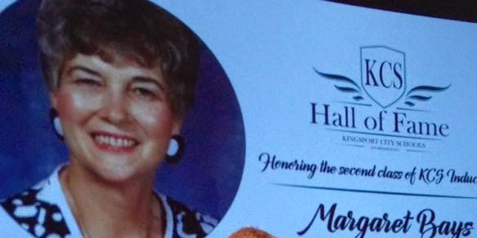 Margaret retired from KCS in 2010 after more than 58 years in education and more than 30 of those years with KCS. During her tenure, she taught music to thousands of students at Johnson Elementary School. In retirement, she has continued to be involved with music activities at many schools.

Lib Dudney retired from KCS in 1985 after serving as a science teacher at both Sevier Junior High and Dobyns-Bennett High schools. Identified by her students as a creative teacher who made science “a wonderland of curiosity and adventure,” Lib was zealous about offering students the best opportunities available to expand their horizons.

Iota Chapter has been so fortunate to have these two outstanding teachers as members!